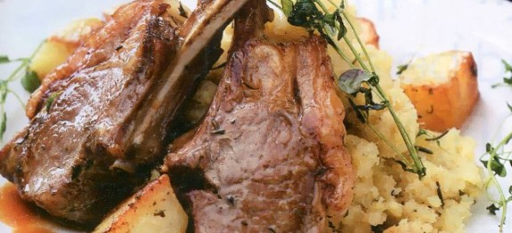

**Thyme Lamb with Rosemary Swede**

**Ingredients:**

* 1kg (2lb) potatoes, peeled and cut into cubes
* 8 lamb loin chops
* 6 tablespoons olive oil
* 125g (4oz) butter
* A handful of fresh thyme sprigs
* Rock salt
* 1 medium swede, peeled and cut into cubes
* 6-8 sprigs rosemary
* Freshly ground black pepper

**For the garnishing:**

* 4 tablespoons olive oil
* A handful of fresh thyme leaves

**Method:**

1. Set the oven to fairly hot, Gas Mark 6 or 220°C/400°F.
2. Cover the potato cubes with water, bring to the boil and simmer for 5-6 minutes, until just tender. Drain
3. Place the lamb chops in a roasting tin with the potatoes. Drizzle with oil and dot with 60g (2oz) butter. Scatter the thyme and rock sat over and cover with damp greaseproof paper.
4. Cook for 15 minutes. Remove the paper and turn the potatoes and chops over. Return to the hot oven for a further 10-15minutes, until browned and crisp.
5. Put the swede cubes into a pan, cover with water and add the rosemary sprigs. Bring to the boil and simmer gently for 10-15minutes, until tender.
6. Drain and remove all large woody sprigs. Mash the swede with the remaining swede with remaining butter and season with black pepper. Put a large spoonful on a serving plate and arrange the chops and potatoes around the edge.

**To make the garnish:**

1. Heat the oil and fry the thyme sprigs over a high heat for a few seconds. Lift out, drain and scatter over the chops.
2. Serve immediately with vegetables and gravy.

Not suitable for freezing.